**Ministry Staff:**

SW Synod Bishop Dee Pederson D.D. - Southwest Synod: [kristin@swmnelca.ccsend.com](mailto:kristin@swmnelca.ccsend.com)

Pastor Linda Wimmer: [pastorlinda@appletonzion.com](mailto:pastorlinda@appletonzion.com)

Cell: 320-297-0643

Administrative Assistant Demi Roiland @ Zion: 320-289-2216

**Zion Council:**

 President Tim Beyer, VP Kathy Tweten, Secretary Tim Ehrenberg

Treasurer:  Leslie Ehrenberg

Organists: Pati Arnold, Andrea Johnson, Marty Koosmann, Abby VanKempen

**MN Valley Council:**

President Kami Shoenfeld, VP OPEN, Secretary Dawn Olson

Treasurer: Karin Moen

Organists: Karin Moen, Dale Lien, Amber Omland

**Borgund Council:**

President Dane Prestholdt, VP Colby Siegert, Secretary Marcia Kells

Treasurer: Tamie & Brian Bremseth

Organist:  Dorothy Anderson

**Service & Contact Information:**

Church Email: [office@appletonzion.com](mailto:office@appletonzion.com)

Zion Website: [www.appletonzion.com](http://www.appletonzion.com)

Facebook: Zion Lutheran Church

Facebook: Minnesota Valley Lutheran

KLQP FM Radio 92.1 Sundays at 1pm & 7pm

YouTube: Zion Lutheran Appleton/MN Valley Lutheran

Donations for the Radio Broadcast are always welcome!

**Prayer Concerns**: Twila Vaala, Alyce Fust, Joan Bremseth, Luann Hegland, Allen Jensen, Selena Morales, Zander Uluestad (Diane Jensen’s niece's grandson), Lynn Henkelman, Nory Hegland, Mary Aasland, Marlys Van Winkle, Harvey Schwarz, (brother of Elaine Rau), Bob Roggatz, Kari Brown (Molly Erickson’s daughter), Tabe & Kathy Hoppe, Joe Espinoza, Jennifer Gibson (daughter of Barb Gens), Kari Brustuen Paulson (sister of Barb Gens), Christal (Stotesbery) Spah, Chuck Tatge, Barb Gens, and Jody Longman. SW Diocese Africa Companion Synod, and all of those that we hold silently in our hearts.

**ZION LUTHERAN CHURCH**

**Easter Sunday**

Sunday, March 31, 2024

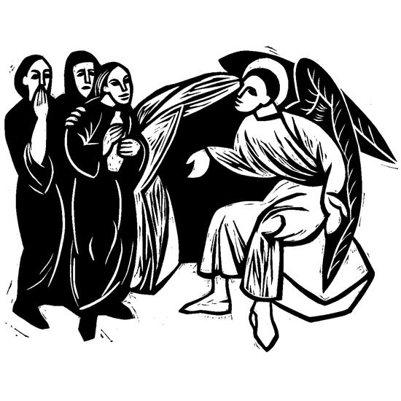

**______________________________________________________________**

*We enter in silence and darkness.*

**HYMN OF REJOICING ELW 365 *“Jesus Christ is Risen Today”***

**EASTER ACCLAMATION**

The Lord is risen.

**He is risen indeed, Alleluia!**

**GREETING & KYRIE p. 203**

**CANTICLE OF PRAISE p. 204**

**PRAYER OF THE DAY** (insert)

**BELLS OF PRAISE *“Thine Is the Glory”***

**MESSAGE FOR ALL GOD’S CHILDREN**

**FIRST READING: Acts 10:34-43**

**PSALM: 118:1-2, 14-24**

**SECOND READING: 1 Corinthians 15:1-11**

**GOSPEL ACCLAMATION p. 205**

**GOSPEL: Mark 16:1-8**

**SERMON**

**HYMN OF THE DAY ELW 367 *“Now All the Vault of Heaven Resounds”***

**NICENE CREED p. 104**

**PRAYERS OF INTERCESSION** (insert)

**PEACE**

**OFFERING: ELW 619 *“I Know That My Redeemer Lives”***

**OFFERING PRAYER**

**GREAT THANKSGIVING p. 206**

***“HOLY, HOLY, HOLY”* p. 207**

**WORDS OF INSTITUTION**

**LORD’S PRAYER p. 208**

**INVITATION TO COMMUNION**

**DISTRIBUTION**

**PRAYER AFTER COMMUNION**

**BLESSING & SENDING**

**THREE-FOLD AMEN**

**SENDING HYMN ELW 376 *“Thine Is the Glory”***

**DISMISSAL**

The Lord is risen.

**He is risen indeed, Alleluia!**

**Copyright © 2023 Augsburg Fortress. All rights reserved.**

**One License #A-719614**

**Zion**

Lector: Roger Boraas

Communion: Roger Boraas

Videotaping: Hope Schmidt

March Ushers: Dan & Kristin Smith

**Zion Altar Guild**

Flowers: Cheryl Schmidt

Communion: Open

Paraments: Kathy Skjei

_________________________________________________________

Thank you Pati Arnold, Lane Schirm, and RJ Koosmann for your musical ministry at Zion today.

*Easter Lily given by* the Roggatz family in memory of Deloris Roggatz.

Join us at Zion Lutheran on Sunday, April 14th at 7pm for the **Agape singers!**



**ANNOUNCEMENTS**

**Today, March 31 - Easter**

-6:30am Easter worship @ Borgund

-8:30am Easter worship @ Zion/Rolls & Coffee following service.

-10:30am Easter worship @ MN Valley

**Wednesday, April 3**

-3:45pm Confirmation Class @ Zion

**Sunday, April 7 - 2 Easter**

-8:30am Borgund worship

-10:30am MN Valley worship

-10:30am Zion worship

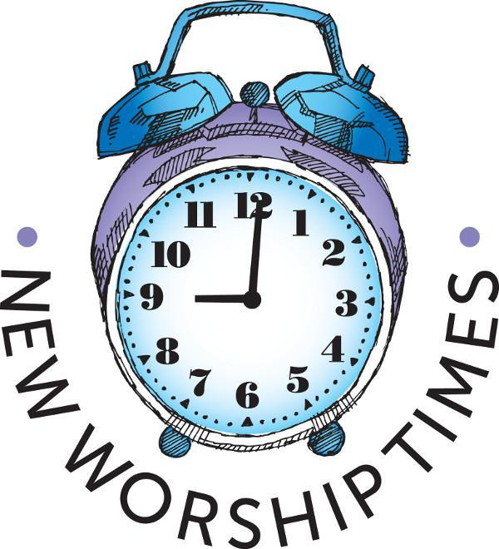

8:30am Borgund worship

10:30am MN Valley worship

10:30am Zion worship

Save the Date!! Minnesota Valley Lutheran Church will be hosting their **drive-thru Klub Supper** on Sunday, April 14th from 4-6 pm. Tickets must be purchased in advance.

Pre-order form <https://forms.gle/N7M418E5kUcm55qd9> or call:

Karin Moen 320-979-6990,

Dawn Olson 320-226-6373,

Lynelle Dahl 320-297-0713, or

Dawn Hegland 320-808-7822

This will be a drive-thru event in the church parking lot

(3304 261st Ave. Louisburg, MN)

* $15/meal includes 2 klub, ham, caramel carrots, coleslaw and cookie
* Klub only 5/$15 or 10/$30

Come and celebrate ***Floyd Eliason’s 90th Birthday*** at the VFW in Appleton from 1 - 4pm on Saturday, April 6th. Everyone is welcome and please, no gifts.

Reminder: Thrivent Choice Dollars are due at the end of March. 1-800-847-4836. A representative will help you direct Choice Dollars to the organization of your choice.

**Zion is seeking Delegates** to represent Zion by attending the Synod Assembly June 7-8th. This may be in person or via Zoom. Please contact the Zion office for more information.

**Spring Gathering Tuesday, April 16 at Barfield Lutheran Church**

2018 180th St. Madison, MN.

9am Registration, coffee & treats

10am Program & Songs from Little Blessings Preschool

Men & Women are invited to join us to hear from Kim Derich about her experience & mission work in Guatemala.

$5 Registration fee will be paid by the ZLCW.

If interested please contact the office at 320-289-2216. Your registration must be received by the office at Zion by April 5th.

*Open house bridal shower honoring Kayla Lagro bride to be of Thomas Hastad on*

*Saturday, April 13, 2024 from 1:30 p.m. to 3:30 p.m. at the Mark & Trudy Hastad farm,*

*2818 241st Ave, Madison, MN. The couple are registered at Amazon & Target.*

Rev. Linda will be away Easter Monday and Tuesday, April 2nd. If in need of pastoral care please contact Rev. Isder at 320-734-4455 or email [klcpastork@gmail.com](mailto:klcpastork@gmail.com)

