**Ministry Staff:**

SW Synod Bishop Dee Pederson D.D. - Southwest Synod: [kristin@swmnelca.ccsend.com](mailto:kristin@swmnelca.ccsend.com)

Pastor Linda Wimmer: [pastorlinda@appletonzion.com](mailto:pastorlinda@appletonzion.com)

Cell: 320-297-0643

Administrative Assistant Demi Roiland @ Zion: 320-289-2216

**Zion Council:**

 President Ritchie Voorhees, VP Matt Tollefson, Secretary Tim Ehrenberg

Treasurer:  Leslie Ehrenberg

Organists: Pati Arnold, Andrea Johnson, and Marty Koosmann

**MN Valley Council:**

President Dale Lien, VP Kami Schoenfeld, Secretary Dawn Olson

Treasurer: Karin Moen

Organists: Karin Moen, Dale Lien, Amber Omland

**Borgund Council:**

President Ron Sigdahl, VP Dane Prestholdt, Secretary Marcia Kells

Treasurer: Tamie & Brian Bremseth

Organist:  Dorothy Anderson

**Service & Contact Information:**

Church Email: [office@appletonzion.com](mailto:office@appletonzion.com)

Zion Website: [www.appletonzion.com](http://www.appletonzion.com)

Facebook: Zion Lutheran Church

Facebook: Minnesota Valley Lutheran

KLQP FM Radio 92.1 Sundays at 1pm & 7pm

YouTube: Zion Lutheran Appleton/MN Valley Lutheran

**Prayer Concerns**: Selena Morales, Zander Uluestad (Diane Jensen’s niece's grandson), Lynn Henkelman, Nory Hegland, Mary Aasland, Marlys Van Winkle, Harvey Schwarz, (brother of Elaine Rau), Bob Roggatz, Kari Brown (Molly Erickson’s daughter), Tabe & Kathy Hoppe, Joe Espinoza, Jennifer Gibson (daughter of Barb Gens), Christopher Kepner, Kari Brustuen Paulson (sister of Barb Gens), Christal (Stotesbery) Spah, Chuck Tatge, Barb Gens, and Jody Longman. SW Diocese Africa Companion Synod, and all of those that we hold silently in our hearts.

**ZION LUTHERAN**

**FOURTH SUNDAY AFTER EPIPHANY**

Sunday, January 28th, 2024



**______________________________________________________________**

**WELCOME & ANNOUNCEMENTS**

**CONFESSION & FORGIVENESS p. 94**

**GATHERING HYMN ELW 665 *“Rise, Shine, You People!”***

**GREETING**

**PRAYER OF THE DAY** (insert)

**MESSAGE FOR ALL GOD’S CHILDREN**

(Zion SS children dismissed)

**FIRST READING: Deuteronomy 18:15-20**

**PSALM 111**

**SECOND READING: 1 Corinthians 8:1-13**

**GOSPEL ACCLAMATION p. 142**

**GOSPEL: Mark 1:21-28**

**SERMON**

**HYMN OF THE DAY ELW 612 *“Healer of Our Every Ill”***

**APOSTLES CREED p. 105**

**PRAYERS OF INTERCESSION** (insert)

**PEACE**

**OFFERING: ELW 840 *“Now Thank We All Our God”*** (verse 1)

**OFFERING PRAYER**

**WORDS OF INSTITUTION**

**LORD’S PRAYER p. 145**

**INVITATION TO COMMUNION**

**PRAYER AFTER COMMUNION**

**BLESSING & SENDING**

**THREE-FOLD AMEN**

**SENDING HYMN ELW 434 *“Jesus Shall Reign”***

**DISMISSAL**

**sundaysandseasons.com.**

**Copyright © 2023 Augsburg Fortress. All rights reserved.**

**One License #A-719614**

_________________________________________________________

**Zion**

Lector: Lane Schirm

Communion: Shelly Schirm

Videotaping: Ritchie Voorhees

January Ushers:Roger Boraas

**Zion Altar Guild**

Flowers: Alyce Fust

Communion: Diane Kepner

Paraments: Need Volunteer

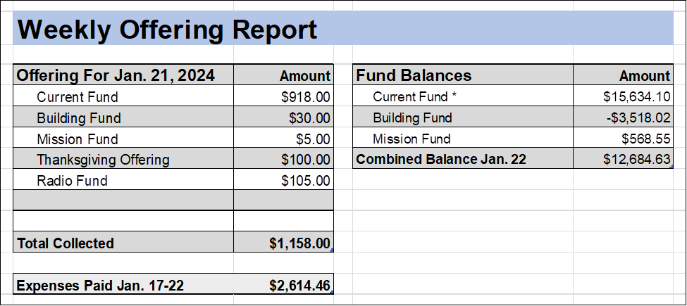

__________________________________

**Lenten Service Schedule**

February 14 Ash Wednesday: 7pm service @ Borgund

February 21: 6pm supper with the 7pm Lenten service to follow

at MN Valley Lutheran Church.

February 28: 6pm supper with a 7pm Lenten service to follow at Zion Lutheran Church.

March 6: 7pm Lenten service at Borgund with bars to follow.

March 13: 6pm supper with a Lenten service to follow at MN

Valley Lutheran Church.

March 20: 6pm supper with a Lenten service to follow at Zion

Lutheran Church.

**ANNOUNCEMENTS**

**Today, January 28: 4 Epiphany**

  - 8:30am Zion Worship/Annual mtg.

  - 8:30am - 1pm Appleton VFW Brunch

  - 10:30am Borgund Worship

  - 10:30am MN Valley Worship

-11am - 1pm Benefit for Rev. Bruce Bringle @ Madison VFW

**Monday, January 29**

-7pm Parent Confirmation mtg. via Zoom

**Wednesday, January 31**

-3:45pm Tri-Church Confirmation @ Zion

-7pm Tri-Church Council mtg. @ MN Valley

**Sunday, February 4: 5 Epiphany**

-8:30am Zion Worship with Spoken Liturgy

-10:30am Joint Worship/Souper Bowl of Caring @ Borgund

**Wednesday, February 7**

-3:45pm Tri-Church Confirmation Class @ Zion

**Sunday, February 11 – Transfiguration of Our Lord**

-8:30am Zion Worship

-10:30am Borgund Worship

-10:30am MN Valley Worship

**Today, January 28:** Zion Lutheran’s Annual mtg. following worship.

***The Appleton VFW*** will be having a BRUNCH served today, January 28, 8:30am to 1pm. Those attending Zion’s Annual meeting are encouraged to grab brunch at the VFW after the meeting.

There will also be a pancake **benefit brunch for Pastor Bruce Bringle** today, January 28th at the Madison VFW, serving from 11 am – 1 pm.

**Monday, January 29:** 7pm Parent Confirmation Zoom mtg.

**Wednesday, January 31:**

- 3:45pm Tri-Church Confirmation Class @ Zion Lutheran.

- 7pm Tri-Church Council meeting @ MN Valley.

**Sunday, February 4:** Worship with Spoken Liturgy at Zion at 8:30am.

Joint worship at Borgund at 10:30 a.m.; followed by Souper Bowl of Caring. Please be generous to raise dollars for three local food shelves. In 2023, we raised $2,100! Borgund will supply workers for the dinner, but each church is asked to bring: Two pots of soup; two dozen meat sandwiches; and two pans of bars or two dozen cookies.

At Zion, please sign up on the bulletin board if you are able to make any of these items. If you can’t make it to Borgund, someone from Zion will be glad to bring the items with them.

**Thursday, February 8:** 1pm Women’s Bible Study held at Jane Baldwin’s home (312 HWY 119 Madison, MN). ALL WOMEN ARE WELCOME!

We will again be doing a ***Tri-Church choir*** that will be singing during the Maundy Thursday service. Rehearsals will be after Lenten Services at the various churches. Last year went very well. Thank you to those who sang last year. Looking forward to seeing you all again. Dale Lien has extra copies of music for MN Valley & Borgund singers who are interested. Thank you, Ted Albers-Director

**2023 Annual Meeting Tuesday, February 13, 2024 at Green Lake Bible Camp**

A noon meal will be served, with the business meeting to follow beginning at 1pm. All member congregations are encouraged to send 2 delegates from your congregation. Please let Demi or Rev. Linda know if you would like to attend as a delegate for your congregation.

Thank you, Abby Vankampen for playing at Zion today.