**Ministry Staff:**

SW Synod Bishop Dee Pederson D.D. - Southwest Synod: [kristin@swmnelca.ccsend.com](mailto:kristin@swmnelca.ccsend.com)

Pastor Linda Wimmer: [pastorlinda@appletonzion.com](mailto:pastorlinda@appletonzion.com)

Cell: 320-297-0643

Administrative Assistant Demi Roiland @ Zion: 320-289-2216

**Zion Council:**

 President Tim Beyer, VP Kathy Tweten, Secretary Tim Ehrenberg, Financial Secretary Brenda Oyen

Treasurer:  Leslie Ehrenberg

Organists: Pati Arnold, Andrea Johnson, Marty Koosmann, Abby VanKempen

**MN Valley Council:**

President Kami Schoenfeld, VP OPEN, Secretary Dawn Olson

Treasurer: Karin Moen

Organists: Karin Moen, Dale Lien, Amber Omland

**Borgund Council:**

President Dane Prestholdt, VP Colby Siegert, Secretary Marcia Kells

Treasurer: Tamie & Brian Bremseth

Organist:  Dorothy Anderson

**Service & Contact Information:**

Church Email: [office@appletonzion.com](mailto:office@appletonzion.com)

Zion Website: [www.appletonzion.com](http://www.appletonzion.com)

Facebook: Zion Lutheran Church

Facebook: Minnesota Valley Lutheran

KLQP FM Radio 92.1 Sundays at 1pm & 7pm

YouTube: Zion Lutheran Appleton/MN Valley Lutheran

**Prayer Concerns**: Family and friends of Chad Henneberg. Dave Fust, Twila Vaala, Alyce Fust, Joan Bremseth, Luann Hegland, Allen Jensen, Selena Morales, Zander Uluestad (Diane Jensen’s niece's grandson), Lynn Henkelman, Nory Hegland, Mary Aasland, Marlys Van Winkle, Harvey Schwarz, (brother of Elaine Rau), Bob Roggatz, Kari Brown (Molly Erickson’s daughter), Tabe & Kathy Hoppe, Joe Espinoza, Jennifer Gibson (daughter of Barb Gens), Kari Brustuen Paulson (sister of Barb Gens), Christal (Stotesbery) Spah, Chuck Tatge, Barb Gens, and Jody Longman. Ayethaba Xulu, Nokwanda Nsele, Nontuthuko Ntombela and Alwande Ntombela (Scholarship Students supported by LQP Conference). SW Diocese Africa Companion Synod, and all of those that we hold silently in our hearts.

**BORGUND, MN VALLEY & ZION LUTHERAN**

**6 EASTER**

Sunday, May 5, 2024

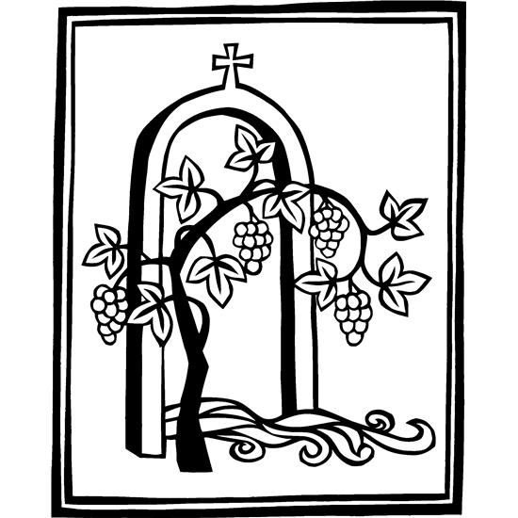

**______________________________________________________________**

**WELCOME & ANNOUNCEMENTS**

**THANKSGIVING FOR BAPTISM**

…and our joy. **Amen.**

Look, here is water!

**Here is our water of life! Alleluia!**

Look, here is water!

**Here is our water of life! Alleluia!**

…now and forever. **Amen.**

Look, here is water!

**Here is our water of life! Alleluia!**

**GATHERING HYMN OSB 220 *“The Old Rugged Cross”***

**GREETING**

**KYRIE p. 203** (Borgund/MN Valley)

**CANTICLE OF PRAISE p. 204** (Borgund/MN Valley)

**PRAYER OF THE DAY** (insert)

**MESSAGE FOR ALL GOD’S CHILDREN**

**FIRST READING: Acts 10:44-48**

**PSALM 98**

**SECOND READING: 1 John 5:1-6**

**GOSPEL ACCLAMATION p. 205**

**GOSPEL: John 15:9-17**

**SERMON**

**HYMN OF THE DAY ELW 654 *“The Church’s One Foundation”***

**APOSTLES CREED p. 105**

**PRAYERS OF INTERCESSION** (insert)

**PEACE**

**OFFERING: ELW 692 *“We are an Offering”***

**OFFERING PRAYER**

**GREAT THANKSGIVING p. 206** (Borgund/MN Valley)

***“HOLY, HOLY, HOLY”* p. 207** (Borgund/MN Valley)

**WORDS OF INSTITUTION** (Borgund/MN Valley)

**LORD’S PRAYER p. 208**

**INVITATION TO COMMUNION** (Borgund/MN Valley)

**DISTRIBUTION** (Borgund/MN Valley)

**PRAYER AFTER COMMUNION** (Borgund/MN Valley)

**BLESSING & SENDING**

**THREE-FOLD AMEN**

**SENDING HYMN ELW 389 *“Christ is Alive”***

**DISMISSAL**

**sundaysandseasons.com.**

**Copyright © 2023 Augsburg Fortress. All rights reserved.**

**One License #A-719614**

**MN Valley**

Ushers: Ross Olson

Communion: Luann Hegland

Lector: Mark & Kami Schoenfeld

Acolyte: Taylynn

Videotaping: Ryan Olson

**Borgund-May**

Ushers: Phil Skurdahl

Communion: Tim Siegert

**Zion**

Lector: Ritchie Voorhees

Communion: Ritchie & Mary Vorhees

Videotaping: Hope Schmidt

**May Ushers: Matt Tollefson & Family**

**Zion Altar Guild**

Flowers: Shelly Schirm

Communion: Connie Stotesbery & Sandy Tatge

Paraments: Pati Arnold

*_________________________________________________________*

**Zion is seeking Delegates** to represent Zion by attending the Synod Assembly June 7-8th. This may be in person or via Zoom. Please contact the Zion office for more information.

**Thank you Sister Kay for leading worship at Zion today.**

_________________________________________________________

**MN Valley 2024 Graduates**

Eli Hegland & Jenna Coil

**Zion 2024 Graduates**

Cael Benson, Claire Borstad, Isabel Gerdes, Keaton Peters,

Grace Vacek

**ANNOUNCEMENTS**

**Today, May 5 - 6 Easter**

-8:30am Borgund worship

-10:30am MN Valley worship

-10:30am Zion worship

**Wednesday, May 8**

-9am Zion Quilting/ZLCW lunch

-7pm Tri-Church Council mtg. @ Zion

**Thursday, May 9**

-3pm Orchard clean up @ Zion

**Sunday, May 12 - 7 Easter**

-8:30am Borgund worship & fellowship to follow

-10:30am MN Valley worship/Recognition of Graduates

-10:30am Zion worship

**Today** is the last day of Sunday School at MN Valley Lutheran.

**Monday, May 6:** Rev. Linda Wimmer will be taking the day off.

**Wednesday, May 8: 7pm Tri-Church Council meeting** held at Zion Lutheran Church. 9am Quilting gathering at Zion with a ZLCW lunch to follow.

AAH will be coming to do an **orchard clean up** on May 9th at 3:00pm. If anyone in the community or congregation wants to join, that would be awesome! We will be pruning the raspberry bushes, spray painting the metal signs, light weeding and working with the mulch. Thank you!

*There will be an open house bridal shower honoring Isabel Schirm, bride-to-be of Dain Haas, on Saturday, May 11, at the Appleton Golf Course. "Come and Go” from 10am to 12pm. The couple is registered at Amazon and Target.*

+ Sunday, May 12 MN Valley will be honoring the 2024 Graduates during the 10:30am worship service. Please come wearing your gown and arrive by 10:15am. You will also be presented with a quilt from the congregation. MN Valley will also have a *Blessing of Quilts* on this day.

**Sunday, May 12** will be the last day of Sunday School at Borgund with coffee, rolls and fellowship following worship.

**Rev. Linda will be attending the Festival of Homiletics Conference Monday, May 13 thru Thursday, May 16.**

+ We will be honoring the 2024 High School Graduates on Sunday, May 19 at the 10:30am worship service at Zion. Please come wearing your gown and meet in the Lounge by 10:15am to receive your boutonniere. You will also be presented with a gift from the congregation. There will be coffee and cake served after the service.

**Sunday, May 19** will also be the last day of Sunday School at Zion. There will be a **Sunday School Bake Sale Fundraiser** this day. Make some memories with your kiddos and help support future Sunday School programming. Please have all baked goods pre-wrapped and to the church by 10am this morning. Baked goods can also be dropped off at Hope Schmidt’s house over the weekend if you are not able to attend church this day. You can price or we can price for you that morning. Kids will work the bake sale table before and after church.

LQP Conference at Southwest MN Synod is sponsoring scholarships for high school students in our companion Synod. Please keep the following students in your prayers: Ayethaba Xulu, Nokwanda Nsele, Nontuthuko Ntombela and Alwande Ntombela.

Open House - Please join us in honoring Isabel Janine Gerdes on Sunday, May 26th from 3:00-7:30 p.m. 1090 140th Ave. NW Watson, MN 56295.