**Ministry Staff:**

SW Synod Bishop Dee Pederson D.D. - Southwest Synod: [kristin@swmnelca.ccsend.com](mailto:kristin@swmnelca.ccsend.com)

Pastor Linda Wimmer: [pastorlinda@appletonzion.com](mailto:pastorlinda@appletonzion.com)

Cell: 320-297-0643

Administrative Assistant Demi Roiland @ Zion: 320-289-2216

**Zion Council:**

 President Ritchie Voorhees, VP Matt Tollefson, Secretary Tim Ehrenberg

Treasurer:  Leslie Ehrenberg

Organists: Pati Arnold, Andrea Johnson, and Marty Koosmann

**MN Valley Council:**

President Dale Lien, VP Kami Schoenfeld, Secretary Dawn Olson

Treasurer: Karin Moen

Organists: Karin Moen, Dale Lien, Amber Omland

**Borgund Council:**

President Dane Prestholdt, VP Colby Siegert, Secretary Marcia Kells

Treasurer: Tamie & Brian Bremseth

Organist:  Dorothy Anderson

**Service & Contact Information:**

Church Email: [office@appletonzion.com](mailto:office@appletonzion.com)

Zion Website: [www.appletonzion.com](http://www.appletonzion.com)

Facebook: Zion Lutheran Church

Facebook: Minnesota Valley Lutheran

KLQP FM Radio 92.1 Sundays at 1pm & 7pm

YouTube: Zion Lutheran Appleton/MN Valley Lutheran

**Today’s Radio Broadcast** is sponsored by Don & Danica Tweet. Thank you!

**Prayer Concerns**: Allen Jensen, Selena Morales, Zander Uluestad (Diane Jensen’s niece's grandson), Lynn Henkelman, Nory Hegland, Mary Aasland, Marlys Van Winkle, Harvey Schwarz, (brother of Elaine Rau), Bob Roggatz, Kari Brown (Molly Erickson’s daughter), Tabe & Kathy Hoppe, Joe Espinoza, Jennifer Gibson (daughter of Barb Gens), Christopher Kepner, Kari Brustuen Paulson (sister of Barb Gens), Christal (Stotesbery) Spah, Chuck Tatge, Barb Gens, and Jody Longman. SW Diocese Africa Companion Synod, and all of those that we hold silently in our hearts.

**BORGUND, MN VALLEY & ZION LUTHERAN**

**Fourth Sunday in Lent**

Sunday, March 10th, 2024

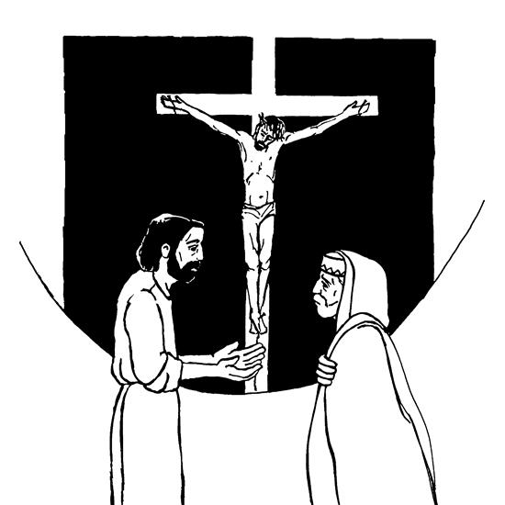

**______________________________________________________________**

**WELCOME & ANNOUNCEMENTS**

**ZION PRAYER SHAWL BLESSING** (Zion)

**CONFESSION & FORGIVENESS p. 94**

**GATHERING HYMN ELW 592 *“Just As I Am Without One Plea”***

**GREETING AND KYRIE p. 156**

**CANTICLE OF PRAISE p. 159**

**PRAYER OF THE DAY** (insert)

**MESSAGE FOR ALL GOD’S CHILDREN**

(Zion SS children dismissed)

**FIRST READING: Numbers 21:4-9**

**PSALM: 107:1-3, 17-22**

**SECOND READING: Ephesians 2:1-10**

**GOSPEL ACCLAMATION p. 160**

**GOSPEL: John 3:14-21**

**SERMON**

**HYMN OF THE DAY 660 *“Lift High the Cross”***

**APOSTLES CREED p. 105**

**PRAYERS OF INTERCESSION** (insert)

**PEACE**

**OFFERING: ELW 686 *“We Give Thee But Thine Own”***

(verse 1)

**OFFERING PRAYER**

**GREAT THANKSGIVING p. 161** (Zion, MN Valley)

**WORDS OF INSTITUTION** (Zion, MN Valley)

***“HOLY, HOLY, HOLY”* p. 153** (Zion, MN Valley)

**LORD’S PRAYER p. 163**

**INVITATION TO COMMUNION** (Zion, MN Valley)

**PRAYER AFTER COMMUNION** (Zion, MN Valley)

**BLESSING & SENDING**

**THREE-FOLD AMEN**

**SENDING HYMN ELW 779 *“Amazing Grace, How Sweet the Sound”***

**DISMISSAL**

**sundaysandseasons.com.**

**Copyright © 2023 Augsburg Fortress. All rights reserved.**

**One License #A-719614**

**MN Valley**

Ushers: Dale Lien

Communion: Don Tweet

Lector: Paul & Amanda Lowry

Acolytes: Tyler

Videotaping: Scott Omland

**Borgund-March**

Dane & Heidi Prestholdt

Phil Skurdahl

**Zion**

Lector: Dan & Kristin Smith

Communion: Dan & Kristin Smith

Videotaping: Wade Schmidt

March Ushers: Dan & Kristin Smith

**Zion Altar Guild**

Flowers: Open

Communion: Diane Kepner

Parament: Kathy Skjei

_________________________________________________________

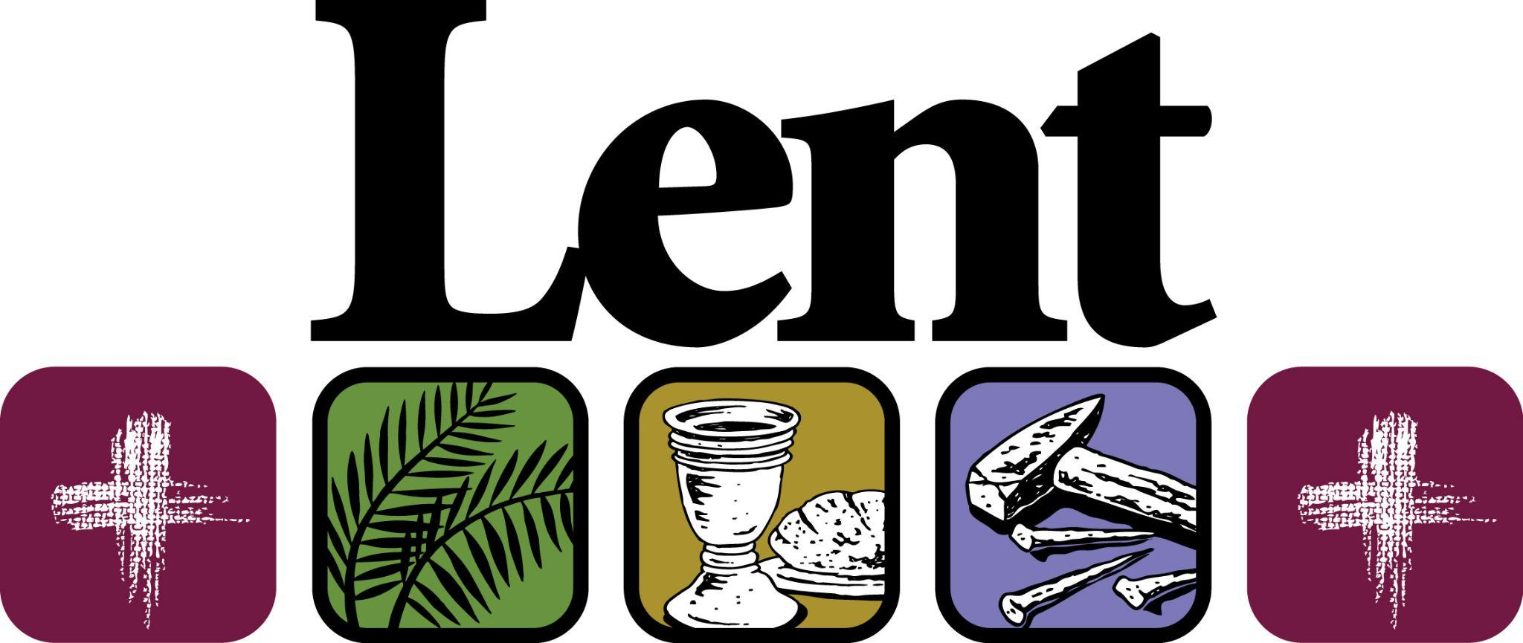

* **March 13:** 6pm supper

7pm Lenten service to follow at MN Valley Lutheran Church.

* **March 20:** 6pm supper

7pm Lenten service to follow at Zion Lutheran Church.

We will again be doing a ***Tri-Church choir*** that will be singing during the Maundy Thursday service. **Rehearsals will be after Lenten Services at the various churches. All are welcome!** Last year went very well. Thank you to those who sang last year. Looking forward to seeing you all again. Dale Lien has extra copies of music for MN Valley & Borgund singers who are interested. Thank you, Ted Albers-Director

**ANNOUNCEMENTS**

**Today, March 10 - Fourth Sunday in Lent**

-8:30am Zion Worship

-10:30am Borgund Worship

-10:30am MN Valley Worship

**Wednesday, March 13**

-3:45 Tri-Church Confirmation Class @ Zion

-6pm Supper @ MN Valley

-7pm Lenten worship @ MN Valley

**Thursday, March 14**

-1pm Women’s Bible Study @ The Madison Lutheran Chapel

**Sunday, March 17 - Fifth Sunday in Lent**

-8:30am Zion Worship

-10:30am Borgund Worship

-10:30am MN Valley Worship

**Wednesday, March 13:**

3:45pm Tri-Church Confirmation Class at Zion Lutheran.

6pm supper at MN Valley Lutheran.

7pm Lenten worship at MN Valley following supper.

**Thursday, March 14:** 1pm Women’s Bible Study held at Madison Lutheran Home Chapel.

Save the Date!! Minnesota Valley Lutheran Church will be hosting their drive-thru Klub Supper on Sunday, April 14th from 4-6 pm. Tickets must be purchased in advance.

**You are invited to join the Benson community in “A Journey through Holy Week-The Seven Days”** which will be given at Our Redeemer’s Lutheran Church on Palm Sunday evening, March 24th at 7:00pm.

The program will be a message in Scripture, Organ music and Song.

Pastor Gary Mills will play the organ and a community choir will sing four numbers. We are inviting singers from the area to join in the choir practices for three Sunday evenings on March 3rd, 10th and 17th at 6:00 pm at Our Redeemer’s. There will be congregational singing of traditional Lenten hymns as well. A Free will offering to the local Food Shelf will be available. Please plan to make this a part of your Holy Week.

Alongside area churches, we are invited to participate in the **“Love Your Neighbor”** donation opportunity to benefit the LQP food shelf and Appleton food shelf. The food shelves are asking for “everyday” type items: paper towels, toilet paper, soap, toothpaste, diapers, baby wipes, etc. A second option for you is to give cash – make your check to your congregation with “food shelf” in the memo line. Please consider giving a boost to the local food shelves by giving in one of these two ways! Thank you!

________________________________________________________



**March 28, Maundy Thursday:** 7pm worship service at MN Valley Lutheran Church. Tri-Church Choir performance.

**March 29, Good Friday:** 7pm worship service at Zion Lutheran Church.

**March 31, Easter:**

6:30am Borgund Easter worship

8:30am Zion Easter worship

10:30am MN Valley Easter worship