**Ministry Staff:**

SW Synod Bishop Dee Pederson D.D. - Southwest Synod: [kristin@swmnelca.ccsend.com](mailto:kristin@swmnelca.ccsend.com)

Pastor Linda Wimmer: [pastorlinda@appletonzion.com](mailto:pastorlinda@appletonzion.com)

Cell: 320-297-0643

Administrative Assistant Demi Roiland @ Zion: 320-289-2216

**Zion Council:**

 President Tim Beyer, VP Kathy Tweten, Secretary Tim Ehrenberg, Financial Secretary Brenda Oyen

Treasurer:  Leslie Ehrenberg

Organists: Pati Arnold, Andrea Johnson, Marty Koosmann, Abby VanKempen

**MN Valley Council:**

President Kami Schoenfeld, VP OPEN, Secretary Dawn Olson

Treasurer: Karin Moen

Organists: Karin Moen, Dale Lien, Amber Omland

**Borgund Council:**

President Dane Prestholdt, VP Colby Siegert, Secretary Marcia Kells

Treasurer: Tamie & Brian Bremseth

Organist:  Dorothy Anderson

**Service & Contact Information:**

Church Email: [office@appletonzion.com](mailto:office@appletonzion.com)

Zion Website: [www.appletonzion.com](http://www.appletonzion.com)

Facebook: Zion Lutheran Church

Facebook: Minnesota Valley Lutheran

KLQP FM Radio 92.1 Sundays at 1pm & 7pm

YouTube: Zion Lutheran Appleton/MN Valley Lutheran

**Prayer Concerns**: Darlene Vaala, Dave Fust, Twila Vaala, Alyce Fust, Joan Bremseth, Allen Jensen, Selena Morales, Zander Uluestad (Diane Jensen’s niece's grandson), Lynn Henkelman, Nory Hegland, Mary Aasland, Marlys Van Winkle, Harvey Schwarz, (brother of Elaine Rau), Bob Roggatz, Kari Brown (Molly Erickson’s daughter), Tabe & Kathy Hoppe, Joe Espinoza, Jennifer Gibson (daughter of Barb Gens), Kari Brustuen Paulson (sister of Barb Gens), Christal (Stotesbery) Spah, Chuck Tatge, Barb Gens, and Jody Longman. Ayethaba Xulu, Nokwanda Nsele, Nontuthuko Ntombela and Alwande Ntombela (Scholarship Students). SW Diocese Africa Companion Synod, and all of those that we hold silently in our hearts.

**BORGUND & ZION LUTHERAN**

**7 EASTER**

Sunday, May 12, 2024

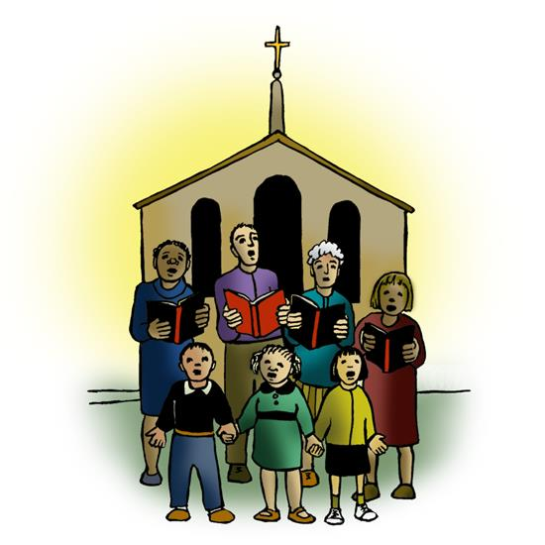

**______________________________________________________________**

**WELCOME & ANNOUNCEMENTS**

**THANKSGIVING FOR BAPTISM p. 97**

**GATHERING HYMN ELW 392 *“Alleluia! Sing to Jesus”***

**GREETING & KYRIE p. 203**

**CANTICLE OF PRAISE p. 204**

**PRAYER OF THE DAY** (insert)

**MESSAGE FOR ALL GOD’S CHILDREN**

**FIRST READING: Acts 1:15-17, 21-26**

**PSALM 1**

**SECOND READING: 1 John 5:9-13**

**GOSPEL ACCLAMATION p. 205**

**GOSPEL: John 17:6-19**

**SERMON**

**HYMN OF THE DAY ELW 655 *“Son of God, Eternal Savior”***

**APOSTLES CREED p. 105**

**PRAYERS OF INTERCESSION** (insert)

**PEACE**

**OFFERING: ELW 692 *“We are an Offering”***

**OFFERING PRAYER**

**GREAT THANKSGIVING p. 206** (Borgund)

***“HOLY, HOLY, HOLY”* p. 207** (Borgund)

**WORDS OF INSTITUTION** (Borgund)

**LORD’S PRAYER p. 208**

**INVITATION TO COMMUNION** (Borgund)

**DISTRIBUTION** (Borgund)

**PRAYER AFTER COMMUNION** (Borgund)

**BLESSING & SENDING**

**THREE-FOLD AMEN**

**SENDING HYMN ELW 855 *“Crown Him with Many Crowns”***

**DISMISSAL**

**sundaysandseasons.com.**

**Copyright © 2023 Augsburg Fortress. All rights reserved.**

**One License #A-719614**

**Thank you Sister Kay for leading worship at Zion today.**

_________________________________________________________

**Borgund-May**

Ushers: Phil Skurdahl

Communion: Tim Siegert

**Zion**

Lector: Matt Tollefson

Communion: Tollefson Family

Videotaping: Ritchie Voorhees

**May Ushers: Matt Tollefson & Family**

**Zion Altar Guild**

Flowers: Shelly Schirm

Communion: Connie Stotesbery & Sandy Tatge

Paraments: Pati Arnold

*_________________________________________________________*



**MN Valley Lutheran - Congratulations Class of 2024!!**

Eli Hegland

Jenna Coil

**ANNOUNCEMENTS**

**Today, May 12 - 7 Easter**

-8:30am Borgund worship & fellowship to follow

-10:30am MN Valley worship/Recognition of Graduates

-10:30am Zion worship

**Wednesday, May 15**

-Apple Ridge worship

-1pm Zion Prayer Shawl @ Apple Ridge

**Sunday, May 19 - Day of Pentecost**

-8:30am Borgund worship

-10:30am MN Valley worship

-10:30am Zion worship/Recognition of Graduates

-2pm VBS mtg. @ Zion

-6pm-7pm Boy Scouts @ Zion

+ Today, May 12 MN Valleywill be honoring the 2024 Graduates during the 10:30am worship service. MN Valley will also have a *Blessing of Quilts* today.

**Today, May 12** will be the last day of Sunday School at Borgund with coffee, rolls and fellowship following worship.

**Rev. Linda will be attending the Festival of Homiletics Conference Monday, May 13 thru Thursday, May 16.**

+ We will be honoring the 2024 High School Graduates on Sunday, May 19 at the 10:30am worship service at Zion. Please come wearing your gown and meet in the Lounge by 10:15am to receive your boutonniere. You will also be presented with a gift from the congregation. There will be coffee and cake served after the service.

**Zion 2024 Graduates**

Cael Benson, Claire Borstad, Isabel Gerdes, Keaton Peters,

Grace Vacek

**Sunday, May 19** will also be the last day of Sunday School at Zion. There will be a **Sunday School Bake Sale Fundraiser** this day. Make some memories with your kiddos and help support future Sunday School programming. Please have all baked goods pre-wrapped and to the church by 10am this morning. Baked goods can also be dropped off at Hope Schmidt’s house over the weekend if you are not able to attend church this day. You can price or we can price for you that morning. Kids will work the bake sale table before and after church.

**Sunday, May 19:** 2pm VBS meeting held at Zion Lutheran Church.

LQP Conference at Southwest MN Synod is sponsoring scholarships for high school students in our companion Synod. Please keep the following students in your prayers: Ayethaba Xulu, Nokwanda Nsele, Nontuthuko Ntombela and Alwande Ntombela.

Open House - Please join us in honoring Isabel Janine Gerdes on Sunday, May 26th from 3:00-7:30 p.m. 1090 140th Ave. NW Watson, MN 56295.

**Sunday, May 26:** 9:30am Milan Beach area worship. Remember to bring along a lawn chair! In case of inclement weather, service will be held at Kviteseid, Milan. Free will donation for coffee and goodiesn provided by Randall’s following worship.

**Monday, May 27 - Memorial Day:** Office Closed.

**Community Picnic** at Madison Park Wednesday, June 5. Food served at 5:30pm with worship to follow at 6:45pm. Remember to bring a lawn chair. Freewill donations go towards the FLY Backpack Program. All are welcome!

Open house 50th Anniversary for Warren & Elaine Rau 🙂

Saturday, June 8 at the Appleton VFW from 2pm-5pm.