**Office Hours:** Monday through Thursday 8am-2pm

**Ministry Staff:**

SW Synod Bishop Dee Pederson D.D. - Southwest Synod: [kristin@swmnelca.ccsend.com](mailto:kristin@swmnelca.ccsend.com)

Pastor Linda Wimmer: [pastorlinda@appletonzion.com](mailto:pastorlinda@appletonzion.com)

Cell: 320-297-0643

Administrative Assistant Demi Roiland @ Zion: 320-289-2216

**Zion Council:**

 President Tim Beyer, VP Kathy Tweten, Secretary Tim Ehrenberg, Financial Secretary Brenda Oyen

Treasurer:  Leslie Ehrenberg

Organists: Pati Arnold, Andrea Johnson, Marty Koosmann, Abby VanKempen

**MN Valley Council:**

President Kami Schoenfeld, VP OPEN, Secretary Dawn Olson

Treasurer: Karin Moen

Organists: Karin Moen, Dale Lien, Amber Omland

**Borgund Council:**

President Dane Prestholdt, VP Colby Siegert, Secretary Marcia Kells

Treasurer: Tamie & Brian Bremseth

Organist:  Dorothy Anderson

**Service & Contact Information:**

Church Email: [office@appletonzion.com](mailto:office@appletonzion.com)

Zion Website: [www.appletonzion.com](http://www.appletonzion.com)

Facebook: Zion Lutheran Church

Facebook: Minnesota Valley Lutheran

KLQP FM Radio 92.1 Sundays at 1pm & 7pm

YouTube: Zion Lutheran Appleton/MN Valley Lutheran

**Zion’s Radio Broadcast this Sunday is sponsored by** Alyce & Dave Fust in celebration of their granddaughter Regan Vig’s wedding to Matt Smothers.

**Prayer Concerns**: Family & Friends of Twila Vaala. Koreen Brustuen, Caleb Cozart, Darlene Vaala, Dave Fust, Alyce Fust, Joan Bremseth, Allen Jensen, Selena Morales, Zander Uluestad (Diane Jensen’s niece's grandson), Nory Hegland, Mary Aasland, Marlys Van Winkle, Harvey Schwarz, (brother of Elaine Rau), Bob Roggatz, Kari Brown (Molly Erickson’s daughter), Tabe & Kathy Hoppe, Jennifer Gibson (daughter of Barb Gens), Christal (Stotesbery) Spah, Chuck Tatge, and Jody Longman; Ayethaba Xulu, Nokwanda Nsele, Nontuthuko Ntombela and Alwande Ntombela (Scholarship Students); SW Diocese Africa Companion Synod, and all of those that we hold silently in our hearts.

**BORGUND, MN VALLEY & ZION LUTHERAN**

**12th Sunday after Pentecost**

Sunday, August 11, 2024

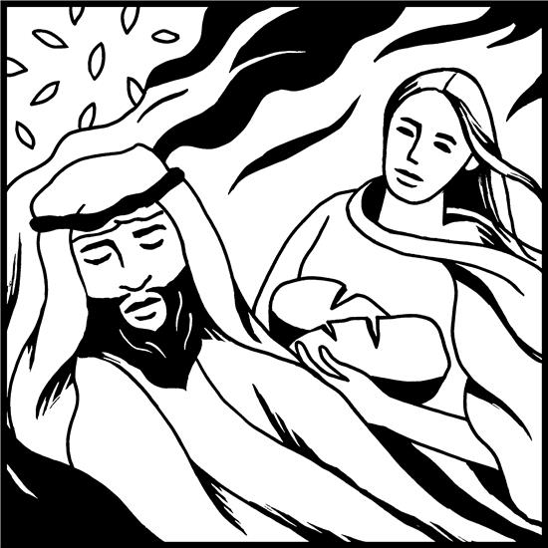

**______________________________________________________________**

**WELCOME & ANNOUNCEMENTS**

**CONFESSION AND FORGIVENESS p. 94**

**GATHERING HYMN ELW 461 *“All Who Hunger, Gather Gladly”***

**GREETING & KYRIE p. 138**

**CANTICLE OF PRAISE p. 140**

**PRAYER OF THE DAY** (insert)

**MESSAGE FOR ALL GOD’S CHILDREN**

**FIRST READING: 1 Kings 19:4-8**

**PSALM 34:1-8**

**SECOND READING: Ephesians 4:25—5:2**

**GOSPEL ACCLAMATION p. 142**

**GOSPEL: John 6:35, 41-51**

**SERMON**

**HYMN OF THE DAY ELW 542 *“O Living Bread from Heaven”***

**APOSTLES CREED p. 105**

**PRAYERS OF INTERCESSION** (insert)

**PEACE**

**OFFERING: ELW 583/685 *“Take My Life That I Might Be”*** (vs.1)

**OFFERING PRAYER**

**GREAT THANKSGIVING p. 144**

***“HOLY, HOLY, HOLY”* p. 144**

**WORDS OF INSTITUTION**

**LORD’S PRAYER p. 145**

**INVITATION TO COMMUNION**

**DISTRIBUTION**

**PRAYER AFTER COMMUNION**

**BLESSING & SENDING**

**THREE-FOLD AMEN**

**SENDING HYMN ELW 618 *“Guide Me Ever, Great Redeemer”***

**DISMISSAL**

**sundaysandseasons.com.**

**Copyright © 2023 Augsburg Fortress. All rights reserved.**

**One License #A-719614**

Thank you Pastor Denise Fossen for leading worship at Zion today.

____________________________________________________

**Borgund-August**

Ushers: Ron & Cindy Sigdahl

Communion: Tim Siegert

**MN Valley**

Ushers: Darby Bjorgan & Family

Communion: Luann H.

Lector: Darby Bjorgan & Family

Acolyte: Haddie

Videotaping: Ryan Olson

**Zion**

Lector: Connie Stotesbery

Communion: Connie Stotesbery

Videotaping: Sara Vacek

**August Usher: Roger Boraas**

**Zion Altar Guild - August**

Flowers: OPEN

Communion: Connie Stotesbery & Sandy Tatge

Paraments: Kathy Skjei

*____________________________________________________*

**Swift County Fair August 14-18**

Thank you to those who helped wash down and clean the Fair Stand last Thursday, August 1st!



**ANNOUNCEMENTS**

**Today, August 11 - Pentecost 12**

-8:30am MN Valley worship

-10:30am Borgund worship

-10:30am Zion worship/Haul supplies to Fair Stand following worship.

**Wednesday, August 14**

-7pm Tri-Church Council mtg. @ Zion

**Sunday, August 18 - Pentecost 13**

-10:30am Tri-Church worship @ MN Valley with potluck & fellowship to follow. Pastor Linda’s last worship in Tri-Church parish.

Secretary, Demi Roiland will be on vacation Saturday, August 10 through Sunday, August 18. Pati Arnold will be covering as secretary during this time.

*Donations of tomatoes and cucumbers for the Zion Food Stand are welcome!!*

We will start PEELING POTATOES and HAULING SUPPLIES TODAY after worship. Please always bring peeled potatoes back to the Church **NOT** to the Fair Stand. Remember to totally cover them with cold water.

Friday, August 16 and Sunday, August 18 we need help washing dish towels. They can be picked up or they can be delivered to you.

**Pastor Linda** will be away to celebrate a wedding on Friday, August 16 and Saturday, August 17.

Wednesday, August 14: 7pm Tri-Church Council meeting held at Zion

Lutheran Church.

Sunday, August 18: 10:30am Tri-Church worship at MN Valley with a POTLUCK dinner and fellowship to follow. This is Pastor Linda’s last worship in Tri-Church parish.

Sunday, August 18 we need help washing dish towels, cleaning and hauling supplies back to the church from the fair stand. We want to faithfully thank those who have volunteered! This is a great fundraiser and without your help this would not be possible.

**MN Valley** will be delivering **Meals on Wheels** in Appleton August 26-30. If you are interested in volunteering to deliver, please sign-up on the bulletin board at MN Valley or call Jane Baldwin.

Head Start is a Federal Program offering FREE preschool for families that qualify. Prairie Five has Head Start classrooms located in elementary schools in all 5 counties. Programs run September-May, four days per week. Serving students 3-5 years old.

For more information contact Prairie Five: [www.prairiefive.org](http://www.prairiefive.org) or call 320-598-3118.

**Intergenerational VBS will be held Sunday, September 15** at Zion starting with worship. Come have faith filled fun for all ages! The day will include options for activities and time in large and small groups.

* 9:45 a.m. VBS Registration
* 10:30 a.m. Worship with Lunch to Follow
* 12 p.m. The Fun Begins!
* Ice Cream Social to Conclude the Day