**Ministry Staff:**

SW Synod Bishop Dee Pederson D.D. - Southwest Synod: [kristin@swmnelca.ccsend.com](mailto:kristin@swmnelca.ccsend.com)

Pastor Linda Wimmer: [pastorlinda@appletonzion.com](mailto:pastorlinda@appletonzion.com)

Cell: 320-297-0643

Administrative Assistant Demi Roiland @ Zion: 320-289-2216

**Zion Council:**

President Ritchie Voorhees, VP Matt Tollefson, Secretary Tim Ehrenberg

Treasurer: Leslie Ehrenberg

Organist: Pati Arnold, Andrea Johnson, Martha Koosmann

**MN Valley Council:**

President Dale Lien, VP Kami Schoenfeld, Secretary Dawn Olson Treasurer: Karin Moen

Organists: Karin Moen, Dale Lien, Amber Omland

**Borgund Council:**

President Ron Sigdahl, VP Dane Prestholdt, Secretary Marcia Kells

Treasurer: Tamie & Brian Bremseth

Organist: Dorothy Anderson

**Service & Contact Information:**

Zion/Borgund/MN Valley Email: [office@appletonzion.com](mailto:zlcappleton@gmail.com)

Zion Website: [www.appletonzion.com](http://www.appletonzion.com)

Facebook: Zion Lutheran Church

Facebook: Minnesota Valley Lutheran

KLQP FM Radio 92.1 Sundays at 1pm & 7pm

YouTube: Zion Lutheran Appleton/MN Valley Lutheran

_________________________________________________________

**Prayer Concerns**: Zander Uluestad (Diane Jensen’s niece's grandson), Lynn Henkelman, Kami Schoenfeld, Marion Ehrenberg, Nory Hegland, Mary Aasland, Marlys Van Winkle, Harvey Schwarz, (brother of Elaine Rau), Bob Roggatz, Kari Brown (Molly Erickson’s daughter), Tabe & Kathy Hoppe, Joe Espinoza, Jennifer Gibson (daughter of Barb Gens), Christopher Kepner, Kari Brustuen Paulson (sister of Barb Gens), Christal (Stotesbery) Spah, Chuck Tatge, Stanley Wilts, Barb Gens, and Jody Longman. SW Diocese Africa Companion Synod, and all of those that we hold silently in our hearts.

**Thanksgiving Eve Service @ Borgund Lutheran Church**

**Wednesday, November 22nd, 2023**

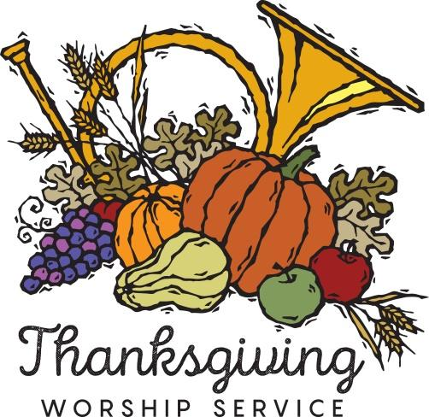

**______________________________________________________________**

**PRELUDE**

**WELCOME & ANNOUNCEMENTS**

**CONFESSION & FORGIVENESS p. 94**

**BORGUND LUTHERAN CHOIR: *“Give Thanks”***

**GREETING AND KYRIE p. 203**

**PRAYER OF THE DAY**

**FIRST READING: Deuteronomy 8:7-18**

**PSALM 65** (After page 338, turn to Psalm 65)

**SECOND READING: 2 Corinthians 9:6-15**

**GOSPEL ACCLAMATION ELW 689 *“Praise and Thanksgiving”*** (verse 1)

**GOSPEL: Luke 17:11-19**

**SERMON**

**HYMN OF THE DAY ELW 825 *“You Servants of God”***

**NICENE CREED p. 104**

**PRAYERS OF INTERCESSION**

**PEACE**

**OFFERING: ELW 188 *“Create in Me a Clean Heart”***

**OFFERING PRAYER**

**GREAT THANKSGIVING p. 206**

**ELW 144 *“Holy, Holy, Holy”***

**LORD’S PRAYER ELW 318** (Sung)

**INVITATION TO COMMUNION**

**ELW 826 *“Thine the Amen”***

**DISTRIBUTION**

**PRAYER AFTER COMMUNION**

**ELW 885 *“Praise God”***

**BLESSING & SENDING**

**THREE-FOLD AMEN**

**SENDING HYMN ELW 836 *“Joyful, Joyful”***

**DISMISSAL**

**sundaysandseasons.com**

**Copyright © 2023 Augsburg Fortress. All rights reserved.**

**One License #A-719614**

**Borgund-November**

Brian & Tammie Bremseth

Phil Skurdahl

**ANNOUNCEMENTS**

**Wednesday, November 22nd – Thanksgiving Service @ Borgund**

-NO CONFIRMATION CLASS

-7pm Tri-Church Thanksgiving worship @ Borgund/Pie to follow

**Thursday, November 23rd – Thanksgiving Day**

-OFFICE CLOSED

**Sunday, November 26th**

-8:30am MN Valley Worship/Baptism of Freya Hastad

-10:30am Borgund Worship/God’s Work Our Hands projects

-10am Coffee/10:30am Zion Worship

**Today:** 7pm Tri-Church Thanksgiving worship service at Borgund Lutheran Church with a pie fellowship to follow.

**Altar Guild** needs help setting up the **Christmas tree** in the Sanctuary at Zion on Friday, November 24th at 9am. Anyone is able to help and your help is greatly appreciated!!

Sunday, Nov. 26: **Borgund** will have a shortened service and will be doing projects for God's Work Our Hands (making care packages to bring to shut-ins) and decorating for Christmas!

Sunday, November 26: Baptism of Freya Hastad at MN Valley Lutheran Church during the 8:30am worship service with rolls and coffee to follow.

**Please support Thankoffering Time!!** Thankoffering will go towards Cancer Transportation and Appleton Hospice. Envelopes will be at the back of the sanctuary. You can drop them off in the office or leave it in the offering plate. Please bring in your offering by Dec. 20th. Thank you!