**Office Hours:** Monday through Thursday 8am-2pm

**Ministry Staff:**

SW Synod Bishop Dee Pederson D.D. - Southwest Synod: [kristin@swmnelca.ccsend.com](mailto:kristin@swmnelca.ccsend.com)

Pastor Linda Wimmer: [pastorlinda@appletonzion.com](mailto:pastorlinda@appletonzion.com)

Cell: 320-297-0643

Administrative Assistant Demi Roiland @ Zion: 320-289-2216

**Zion Council:**

 President Tim Beyer, VP Kathy Tweten, Secretary Tim Ehrenberg, Financial Secretary Brenda Oyen

Treasurer:  Leslie Ehrenberg

Organists: Pati Arnold, Andrea Johnson, Marty Koosmann, Abby VanKempen

**MN Valley Council:**

President Kami Schoenfeld, VP OPEN, Secretary Dawn Olson

Treasurer: Karin Moen

Organists: Karin Moen, Dale Lien, Amber Omland

**Borgund Council:**

President Dane Prestholdt, VP Colby Siegert, Secretary Marcia Kells

Treasurer: Tamie & Brian Bremseth

Organist:  Dorothy Anderson

**Service & Contact Information:**

Church Email: [office@appletonzion.com](mailto:office@appletonzion.com)

Zion Website: [www.appletonzion.com](http://www.appletonzion.com)

Facebook: Zion Lutheran Church

Facebook: Minnesota Valley Lutheran

KLQP FM Radio 92.1 Sundays at 1pm & 7pm

YouTube: Zion Lutheran Appleton/MN Valley Lutheran

**Prayer Concerns**: Madilyn McCambridge (friend of the Kepner’s), Koreen Brustuen, Caleb Cozart, Darlene Vaala, Dave Fust, Twila Vaala, Alyce Fust, Joan Bremseth, Allen Jensen, Selena Morales, Zander Uluestad (Diane Jensen’s niece's grandson), Nory Hegland, Mary Aasland, Marlys Van Winkle, Harvey Schwarz, (brother of Elaine Rau), Bob Roggatz, Kari Brown (Molly Erickson’s daughter), Tabe & Kathy Hoppe, Jennifer Gibson (daughter of Barb Gens), Christal (Stotesbery) Spah, Chuck Tatge, and Jody Longman; Ayethaba Xulu, Nokwanda Nsele, Nontuthuko Ntombela and Alwande Ntombela (Scholarship Students); SW Diocese Africa Companion Synod, and all of those that we hold silently in our hearts.

**MILAN BEACH LAKESIDE WORSHIP**

**7th Sunday after Pentecost**

Sunday, July 7, 2024

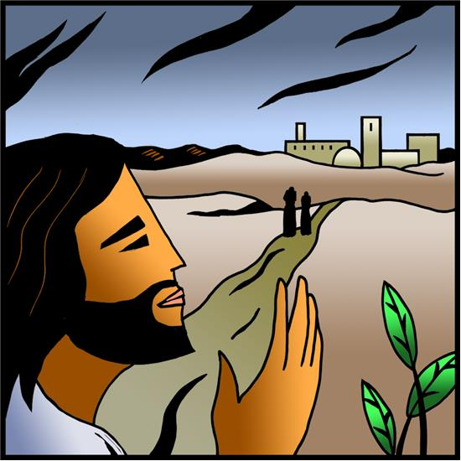

**______________________________________________________________**

**PRELUDE**

**WELCOME & ANNOUNCEMENTS**

**HYMN *“Down to the River to Pray”***

**EXHORTATION AND PRAYER ON A NATIONAL HOLIDAY**

The earth is the Lord’s,

**And all who dwell in it.**

God is king over the nations:

**God sits on his holy throne.**

He rules by his might forever.

**His eyes keep watch on the nations.**

Let the nations be glad and sing for joy,

**For God judges the peoples with equity and guides the nations upon earth.**

May our ways be known upon the earth,

**Your saving power among all peoples.**

Lord of the nations, guide our people by your spirit to go forward in justice and freedom. Above all things, give us faith in you, through your Son, Jesus Christ our Lord.

**Amen.**

**HYMN ELW 888 *“O Beautiful for Spacious Skies”***

**INDEPENDENCE DAY LITANY**

Gracious God, Father of all nations, bless and defend us and our land; prosper the work of our hands, and increase in us your grace and compassion, and our offerings of thanks to you, our rock and our salvation; through Jesus Christ our Lord. **Amen.**

**HYMN *“Nearer My God To Thee”***

**CONFESSION AND FORGIVENESS**

Let us confess our sins to God,

Whose power is made perfect in our weakness.

**Holy God, you call us to boldly proclaim your name,**

**yet we are stubborn and rebellious and heedless of your call.**

**By the power of your Spirit, raise us to new life**

**That we may return to faithful living,**

**in Christ’s name we pray. Amen.**

Sisters and brothers, God’s grace and mercy are never ending. Your sins are forgiven, therefore be at peace. Amen.

**PRAYER OF THE DAY**

God of the covenant, in our baptism you call us to proclaim the coming of your kingdom. Give us the courage you gave the apostles, that we may faithfully witness to your love and peace in every circumstance of life, in the name of Jesus Christ, our Savior and Lord. **Amen.**

**FIRST READING: EZEKIEL 2:1-5**

**PSALM 123**

**SECOND READING: 2 CORINTHIANS 12:8-10**

**GOSPEL: MARK 6:1-13**

**MESSAGE: PASTOR LINDA ESTLING**

**HYMN OF THE DAY ELW 756 *“Eternal Father, Strong to Save”***

**AFFIRMATION OF FAITH**

**OFFERING**

**SPECIAL MUSIC**

**OFFERING PRAYER**

Make us thankful every day, O God, for the gifts that alight upon us from your bounty. Guide us to use these offerings to your glory for the health of your people and this creation. **Amen.**

**PRAYER FOR THE NATION**

**THE LORD’S PRAYER**

**BENEDICTION**

**CLOSING HYMN ELW 890 *“Mine Eyes Have Seen the Glory”***

**CLOSING PRAYER**

**POSTLUDE**

**Message: Pastor Linda Estling**

**Worship Leader: Pastor Linda Wimmer**

**Musical Ministry: Classic Brass**

**ANNOUNCEMENTS**

**Today, July 7 - Pentecost 7**

-9:30am Milan Beach Resort worship

**Sunday, July 14 - Worship Time Change**

-8:30am MN Valley worship

-10:30am Borgund worship

-10:30am Zion worship

**Wednesday, July 17**

-1pm Zion Prayer Shawl @ Apple Ridge

**Sunday, July 21 - Pentecost 9**

-10am Tri-Church worship @ Riverview Park in Appleton

**Today, July 7:** 9:30am Milan Beach Resort worship. Free will donation for coffee and goodies provided by Randall’s following worship.

**Sunday, July 14th - Worship Time Change!!**

8:30am - MN Valley worship

10:30am - Borgund worship

10:30am - Zion worship

Zion will be delivering **Meals On Wheels** July 15-19 and July 22-26. We are in need of volunteers to help deliver. If you are interested, sign-up on the bulletin board across from the office. Even a day or two helps!! Thank you!

**Sunday, July 21:** **10am** Tri-Church worship at Riverview Park in Appleton hosted by Zion Lutheran Church. Come worship & praise in word and song! A potluck picnic will follow worship. *Remember to bring along a lawn chair!!*

The 40th annual Green Lake Lutheran Ministries Quilt Auction will take place Friday, July 26 and Saturday, July 27 at the Green Lake Bible Camp in Spicer! Visit Green Lake Bible Camp to see over 200 handmade quilts, enjoy quilting demonstrations and live music, shop in the Makers Market for your next crafting supplies, enjoy a hotdish supper or pulled pork lunch, a silent auction, bounce house and so much more! Events take place 3:00-8:00 PM on Friday, and 9:00-11:00 AM Saturday, and the live auction starts at 12:00 PM! All proceeds benefit the ministry happening at camp. For more information and schedule of events, visit [www.gllm.org](http://www.gllm.org/)!

**Note Change of Date**

**Intergenerational VBS will be held Sunday, September 15** at Zion starting with worship. Come have faith filled fun for all ages! The day will include options for activities and time in large and small groups.

* 9:45 a.m. VBS Registration
* 10:30 a.m. Worship with Lunch to Follow
* 12 p.m. The Fun Begins!
* Ice Cream Social to Conclude the Day

Please consider donating to the *Radio Fund* at Zion. Broadcasts may be sponsored in honor or memory of a loved one. A service costs $52.50.

MN Valley is in need of a Lector on Sunday, July 14th. Please contact the office if you are available to read this day. 320-289-2216

July 2024 Challenge - Open Your Heart to the Hungry and Homeless

Monetary donations during the July campaign will receive a proportionally matched grant from Open Your Heart to the Hungry and Homeless. Swift County Food Shelf: PO Box 321 - Benson, MN 56215.

Volunteers needed for Caregiver Respite & Support Program. Training will be provided! If you are interested please contact Jamie Aubart at 320-979-4068 or email Jamie.[Aubart@lssmn.org](mailto:Aubart@lssmn.org)

**Pastor Linda Wimmer is on vacation July 11-18.**

Pastor Dawn Quame will provide pastoral care July 11-14.

Pastor Kristine Isder will provide pastoral care July 15-18.

*Pastor Quame:* 507-829-7584

*Pastor Isder:* 320-734-4455 or email [klcpastork@gmail.com](mailto:klcpastork@gmail.com)

**Thank you to the members of Classic Brass for their musical ministry today.**